**Special Right Triangles**

$$45°/45°/90° \text{or } \frac{π}{4}/\frac{π}{4}/\frac{π}{2}$$

Suppose we insert a diagonal into a square with side length $a$. Let’s now focus on the resulting right triangle and determine the hypotenuse and the measure of angle $θ$.

$$θ$$

$a$

Now let’s determine the six trigonometric functions of $θ$.

$\sin\left(θ\right)=$ $\cos\left(θ\right)=$ $\tan{(θ)}=$

$\csc\left(θ\right)=$ $\sec\left(θ\right)=$ $\cot{(θ)}=$

$$30°/60°/90° \text{or} \frac{π}{6}/\frac{π}{3}/\frac{π}{2}$$

Suppose we insert the perpendicular bisector to an equilateral triangle with side length $a.$ Let now focus on the resulting right triangle and determine the missing side lengths.

$$θ$$

$a$

Now let’s determine the six trigonometric functions of $θ$.

$\sin\left(θ\right)=$ $\cos\left(θ\right)=$ $\tan{(θ)}=$

$\csc\left(θ\right)=$ $\sec\left(θ\right)=$ $\cot{(θ)}=$

**Evaluating Trigonometric Functions of Special Angle Measures**

Since trigonometric functions return a ratio from a specific right triangle, the scale of the particular triangle does not matter if we just need the ratio. For example, consider the following:

$$30°$$

$$2$$

$$4$$

$$30°$$

$$3$$

$$6$$

Notice that regardless of the lengths (or scale), $\sin\left(30°\right)=\frac{1}{2}$

Thus, when working with reference angles of $30°, 45°, \text{and} 60° \left(\frac{π}{6},\frac{π}{4}, \text{and}\frac{π}{3}\right)$, we do not necessarily need to know the side lengths (scale).

Example 1: Determine the exact value for each of the following trigonometric expressions.

$sin⁡(45°)$ $\cos{(30°)}$ $\tan\left(\frac{π}{3}\right)$

$\csc\left(\frac{π}{4}\right)$ $\sec\left(\frac{π}{6}\right)$ $\cot{(60°})$

When working with these special reference angles, notice that the possible ratios returned are

$\frac{1}{2}$ $\frac{\sqrt{3}}{3}$ $\frac{\sqrt{2}}{2}$ $\frac{\sqrt{3}}{2}$ $1$ $\frac{2\sqrt{3}}{3}$ $\sqrt{2}$ $\sqrt{3}$ $2$

**The Unit Circle**

The unit circle is nothing more than a reorganization of the information embedded in our two special right triangles and combined with quadrantal angles. The unit circle has a radius of $1$, and thus any triangle created by dropping a perpendicular to the $x$–axis will have a radius (or hypotenuse) of $1$.

Here we see our special right triangles in Quadrant I:

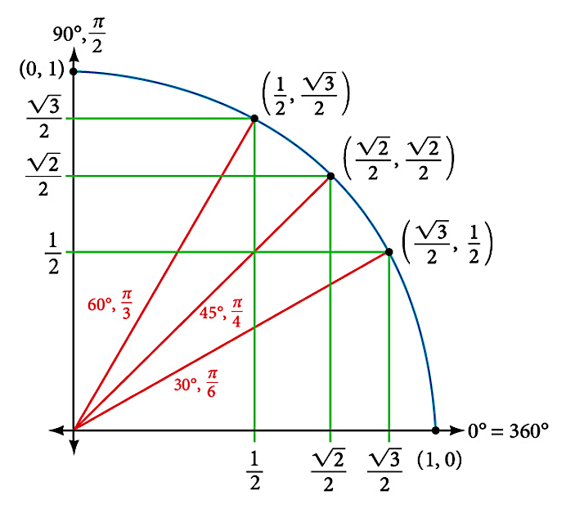

Finally, instead of labeling the base and height of each possible triangle as we rotate through the other quadrants, we instead label the point $(x, y)$ where the terminal side intersects the unit circle. Remember, these are all in standard position.

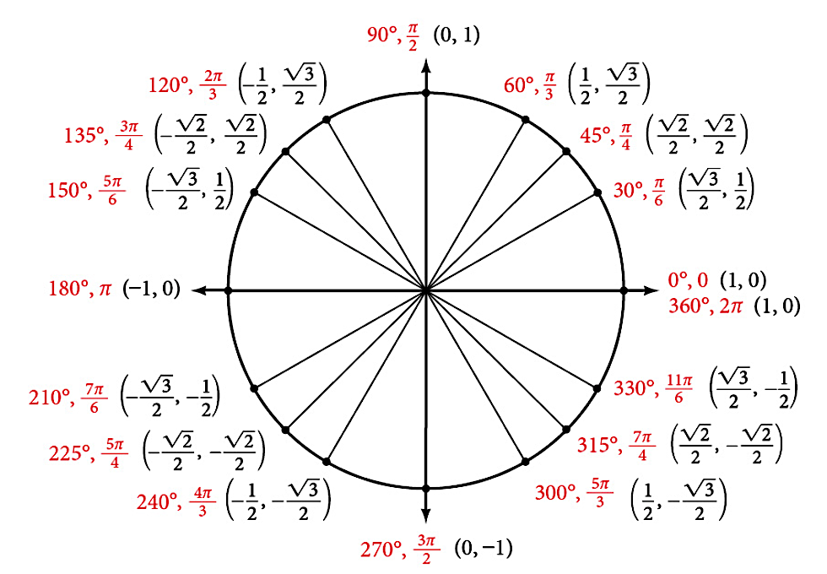

NOTE: When using the unit circle, $\sin\left(θ\right)=y$ and $\cos\left(θ\right)=x$

Example 2: Determine the exact value for each of the following trigonometric expressions.

$\sin\left(\frac{4π}{3}\right)$ $\cos{(315°)}$ $\tan\left(\frac{3π}{2}\right)$

$\csc\left(\frac{5π}{6}\right)$ $\sec\left(\frac{5π}{3}\right)$ $\cot{(135°})$

**Even/Odd Properties**

Even trigonometric function is either even or odd. Recall that for an even function, $f$, $f\left(x\right)=f(-x)$ and for an odd function, $g, g\left(x\right)=-g(-x)$.

Example 3: Use the unit circle to determine whether the following are even or odd functions.

$\sin\left(θ\right)=\frac{y}{r}$

$\cos\left(θ\right)=\frac{x}{r}$

$\tan\left(θ\right)=\frac{y}{x}$

**The Graphs of Sine and Cosine**

The sine and cosine functions have several distinct characteristics:

* They are periodic functions with a period of $2π$
* The domain of each function is $(-∞,∞)$ and the range is $[-1,1]$
* The graph of $f\left(θ\right)=\sin\left(θ\right)$ is symmetric about the origin, because it is an odd function.
* The graph of $g\left(θ\right)=\cos\left(θ\right)$ is symmetric about the $y$–axis, because it is an even function.

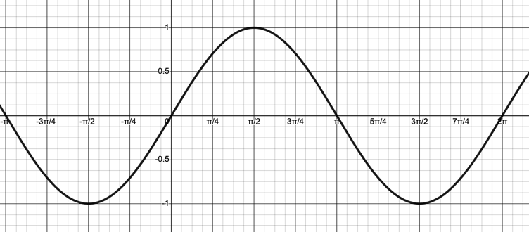 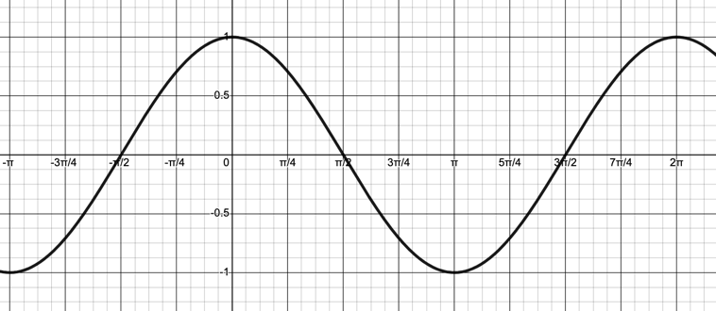

$f\left(θ\right)=sin⁡(θ)$ $g\left(θ\right)=\cos\left(θ\right)$

A function that has the same general shape as a sine or cosine function is known as a **sinusoidal function**. The general forms of a sinusoidal functions are

$f\left(θ\right)=A\sin\left(Bθ-C\right)+D$ and $g\left(θ\right)=A\cos{(Bθ-C)}+D$

In the above general forms, we see there are two multiplicative factors $(A \text{and} B)$ and two additive values $(C \text{and} D).$ These will impact the graph of a sinusoidal function in similar ways to our previous transformations, namely that vertical and horizontal stretches and reflections are impacted by $A \text{and} B$, while vertical and horizontal shifts are impacted by $C \text{and} D.$ However, the terminology changes for these types of functions.

Example 4: Determine the values of $A, B, C, \text{and} D$ for the parent functions:

$f\left(θ\right)=sin⁡(θ)$ $g\left(θ\right)=\cos\left(θ\right)$

**Transformations**

Compared to the parent functions, sinusoidal functions have

$Amplitude=\left|A\right|$ $Period=\frac{2π}{\left|B\right|}$ $Phase Shift=\frac{C}{B}$ $Midline=D$

Amplitude is the vertical height from the midline, Period is the horizontal distance to complete a cycle, Phase Shift is the starting point, and Midline is the line about which the function oscillates above and below.

Example 5: Determine the Amplitude, Period, Phase Shift and Midline for the following sinusoidal functions.

$f\left(θ\right)=3\sin\left(2θ-\frac{π}{3}\right)$

$g\left(θ\right)=-\frac{1}{5}\cos\left(\frac{θ}{3}\right)+2$

$h\left(θ\right)=-\sin\left(\frac{π}{4}θ+π\right)-10$

**Sketching Graphs of Sinusoidal Functions**

To sketch the graph of a sinusoidal function, first determine the amplitude, period, phase shift, and midline. Then use the amplitude and midline to set the output and use the period and phase shift to set the input scale. For example:

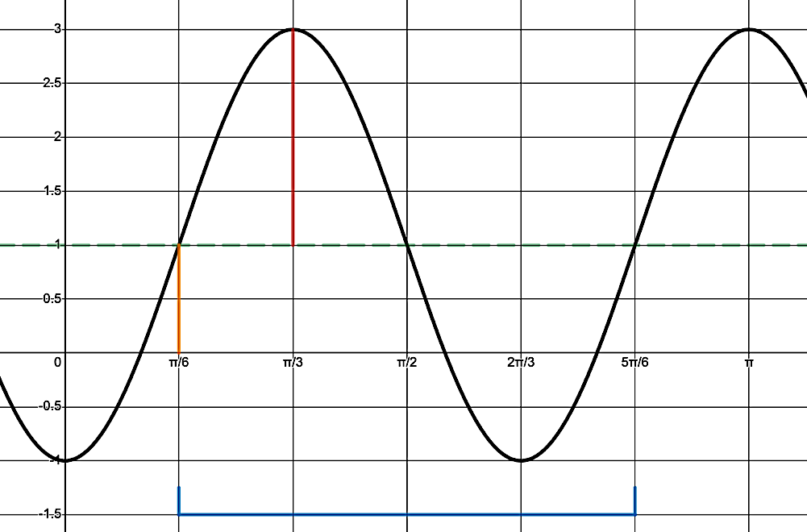

$f\left(θ\right)=2\sin\left(3θ-\frac{π}{3}\right)+1$

$Amplitude=\left|2\right|=2$

$Period=\frac{2π}{\left|3\right|}=\frac{2π}{3}$

$Phase Shift=\frac{\frac{π}{2}}{3}=\frac{π}{6}$

$$Midline=1$$

Example 6: Sketch the graphs of the following sinusoidal functions.





$f\left(θ\right)=3\cos\left(2θ-\frac{π}{2}\right)$

$g\left(θ\right)=-\sin\left(\frac{θ}{2}+\frac{π}{6}\right)+1$

Example 7: Determine a potential sinusoidal function that has the given graph.

